OE-417 E-Filing System
Training Reference Guide
U.S. Department of Energy
Office of Electricity Delivery and Energy Reliability

02/06/2017

OE-417 Training Reference Guide

I. About OE-417 E-Filing 3
II. Registering an Account 4
III. Submitting OE-417 Forms 7
Figure 1 7
A. Submitting a New Form 7
B. Updating Submitted Forms 9
C. Save a Draft for Later Submission 9
D. Submitting as a Guest 10
E. Submitting a Test 11
IV. Organization Management 14
A. Becoming an Organization Administrator 14
B. Organization Admin Responsibilities 14
V. Other Features 16
A. Emailing the Form to NERC 16
B. Search and Export Features 16
Figure 3 16

About OE-417 E-Filing
The OE-417 E-Filing System:
OE-417 Electronic Filing (E-Filing) refers to the updated online filing system for the Electric Emergency Incident and Disturbance Reporting Form (OE-417). Through the OE-417, information is collected on major electric system incidents to inform the Department of Energy (DOE).

Benefits of E-Filing:
For respondents, E-Filing is a convenient, fast, and secure way to submit an OE-417 Form. The updated OE-417 E-Filing also contains the ability to e-mail Forms as they are submitted, assisting companies in fulfilling NERC and other reporting requirements with no additional burden. The E-Filing system is available 24 hours a day, 7 days a week. The OE-417 E-Filing system supports Microsoft Internet Explorer ver. 7.0, 8.0 and 9.0

OE-417 Security:
The OE-417 E-Filing system is a fully secured website hosted at DOE’s National Energy Technology Laboratory (NETL) and adheres to best practices to ensure data and system securities. NETL also ensure compliance with all of DOE’s security policies and procedures.

Features in the OE-417 E-Filing system:
- Secure Login feature to authenticate credentials of individual (registered) respondents prior to granting account access.
- A password recovery system providing respondents the ability to reset/change their own password.
- Ability to submit test OE-417 Forms, allowing respondents to train on the E-Filing system.
- Registered respondent information (such as Organization Name, Address and Additional Point of Contact) are pre/auto-populated into the Form to reduce entry time.
- Ability to update and finalize incident reports without the need to re-enter the entire Form again.
- Ability to save a draft OE-417 Form for later completion/submission.
- Ability to download PDF versions of previous submissions at any time.
- A search engine to find previous OE-417 submissions and export search results.
- Option for delivery of OE-417 Form submission as a .pdf attachment to recipients via e-mail.
- Organization management in order to view and edit other members’ forms

Additional Ways to Submit a Form:
OE-417 submissions will continue be accepted via e-mail, phone and fax.

Contact Us
If you have any questions, contact OE417@hq.doe.gov.

Registering an Account

Registering for an account in the new system takes three steps:
- Click the “I am a new user and need to register” link on the E-Filing home page: https://www.oe.netl.doe.gov/OE417_Form.aspx.
- Complete all required fields and submit
  - Required fields are marked with an *.
  - Note the password requirements in the registration
  - There is a checkbox which can be selected if you are the POC (for lines 13-17 on the OE-417 Form) for your company.
  - If you wish to add e-mail addresses to send Forms to, you must click the ADD button before you click the submit button
- Validate your account upon receiving an e-mail

Step  Step 2 | Description
1 | Click the I am a new user and need to register link on your OE-417 Homepage to create a new account in the OE-417 E-Filing system  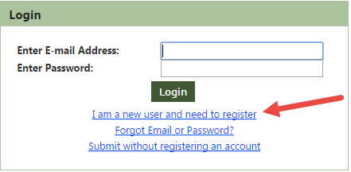
2 | After completing step 1 you will be routed to the registration page, complete all required fields and Click Submit to initiate the account activation process (Refer to FAQ below for a summary of required fields).  Note: If you missed entering any required fields after you click submit and will be prompted to complete all required fields and will need to Click Submit again to complete the submission.  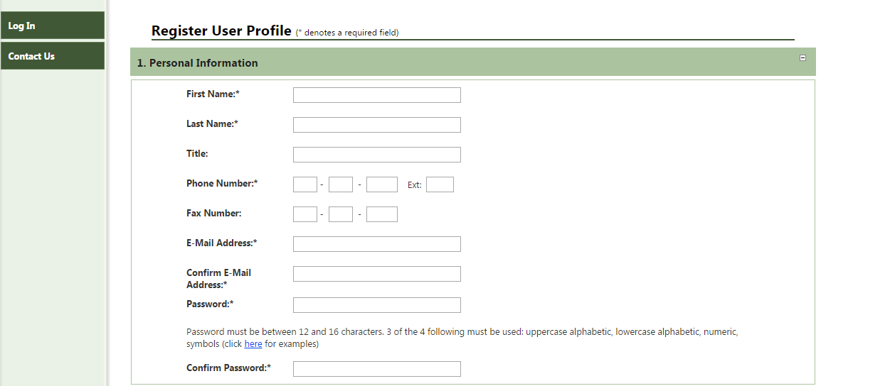
3 | After you have successfully submitted for an account, you will receive an account activation notice at your registered e-mail address. Click the Activate link in that e-mail address to complete the account registration process, after completing this step you will be routed to the OE-417 Login page where you can enter your e-mail/password and start using the new system.  Step 3

FAQ’s on How to Register/Account Management

- What should I do if I have not received a confirmation e-mail after completing the registration process and/or submitting electronic documents?
Prior to contacting the OE office, please verify that your spam filters are not blocking e-mails from OE417@hq.doe.gov. If this is not the problem, please contact the OE E-Filing Help Desk at OE417@hq.doe.gov.

Q. What are the required fields to register for an account?
Required Fields for registration are:
- First Name
- Last
- Phone Number
- Email Address/Confirm E-Mail Address
- Password/Confirm Password
- Point of Contact (Can be the same)
- Three Security Questions and Answers
- Organization Profile

- What is the POC for?
The POC information will appear on the submitted form. They will also receive the e-mail notifications related to the form after submissions.

- How do I select an Organization?
The OE-417 E-Filing system already has a stored list of organization names. To find yours, start typing the name of your organization in the Organization Name field. After three (3) letters typed, an auto-complete list of names will appear. The only except is if your organization name starts with “City of” as the list is very long. The more letters your type in the narrower the list gets.
Select your organization from the drop down list. All other fields will be prepopulated.

- What if my organization name doesn’t appear in the auto-complete list?
You may add your organization by checking the box “Create New Organization”. You should ONLY use this feature if your organization did not appear in the auto-complete list. You will be required to enter in an Address, City, State and Zip Code.

- What is the Organization Admin checkbox for?
Organization Admins manage members of the organization and forms submitted by members. Requesting to be an Organization Admin will send a notification to the System Administrator and they can approve or decline your request.

- How do I become a member of my Organization?
If there is already an Organization Admin for your organization, membership request into the organization will be automatically sent to the Organization Admin for approval. Once approved you will be able to take advantage of the member benefits.
If there is no Organization Admin, then the System Administrator can approve your membership request.

- Why can’t I login?
If you are getting a message that says “incorrect password and/or username” verify your login and password and that your Caps Lock key is not on (your password is case sensitive). If you have forgotten your login or password, click the “Forgot Link or Password” link on the logon screen.

- What should I do if I get a message saying my account is locked?
The system will lock a user’s account after three failed login attempts. If you have locked your account, e-mail the Help Desk at OE417@hq.doe.gov to have it unlocked.

- How do I change my password? Can I update other information like my name, phone number and e-mail address?
All information can be updated. You can change your password or any other user account information at any time by clicking on the "My Account" on the left navigation panel once you are logged in. After you update your information, make sure to reinput your password and then click “Save.”

- Can I check the status of my filing if I submitted a Form without registering an account and logging into the E-Filing system?
No. In order to be able to see past filings, you must create and account, log in, and submit a Form through your account. Users will be able to see all Forms they have submitted.

Submitting OE-417 Forms

The new OE-417 E-Filing system has 4 main features to help respondents to manage their Forms effectively and efficiently.
- Submitting a new Form
- Updating an existing Form
- Saving a draft
- Search function
Note: The purpose of this section of the training reference guide is to help users understand the new features in the E-Filing system. For detailed instructions on how to fill out the OE-417 Form itself, see the Form Instructions.

Figure 1

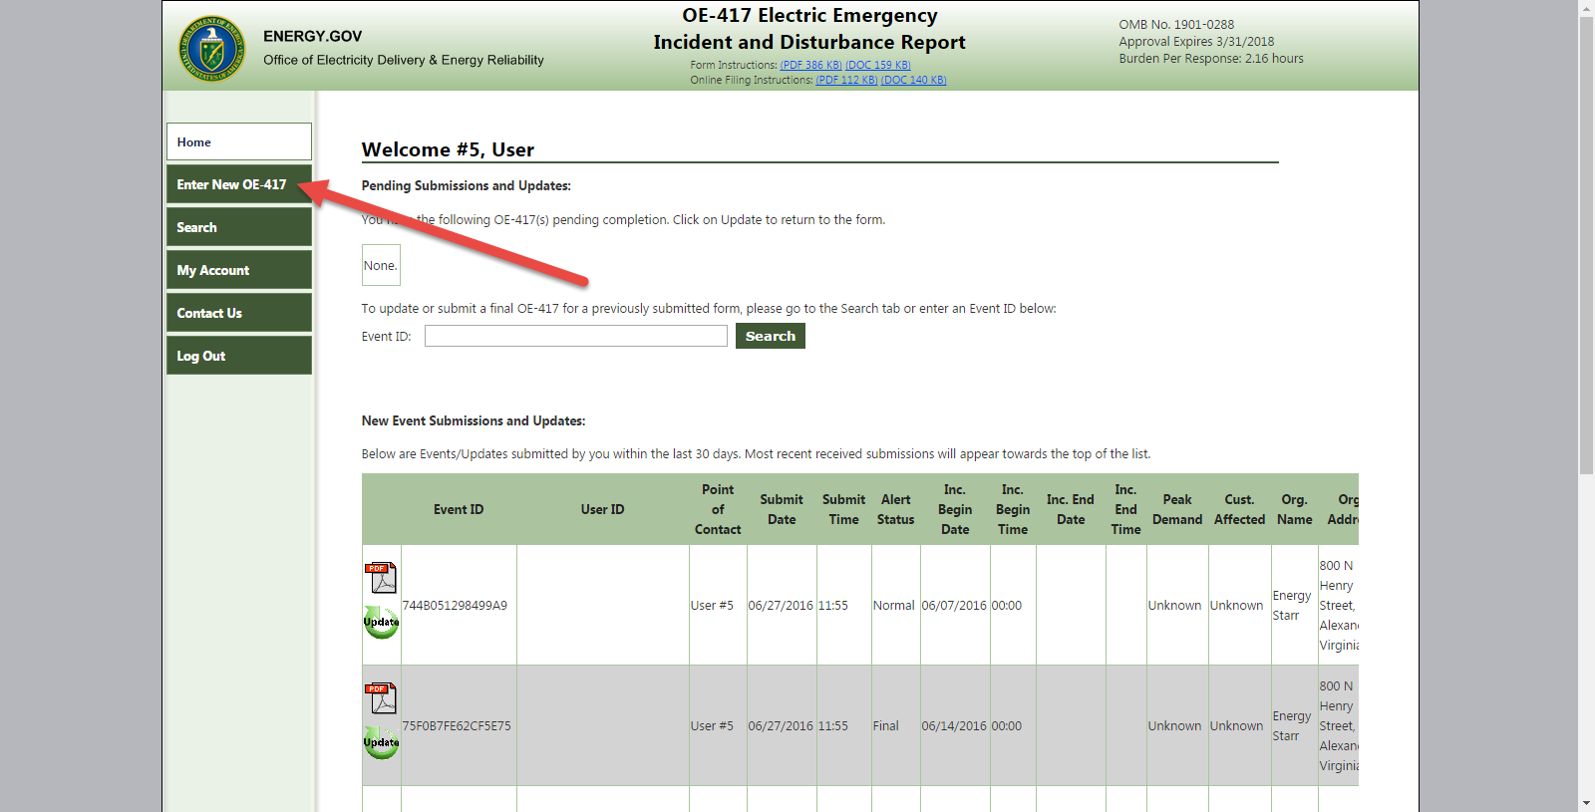

Quick search of Event ID

Step 1

Saving a Draft

Submitting a New Form

Step | Description
1 | Once you have activated your OE-417 account log on with your credentials at  https://www.oe.netl.doe.gov/OE417_Form.aspx.
2 | In your homepage, click on the “Enter New OE-417” button (see Figure 1) to begin a Form submission.  Note: All relevant information in your registration like your name, POC, Organization information will be pre populated for your convenience.
3 | The new OE-417 Form has 5 Key parts that you will need complete the Form submission process.  - Schedule 1 – Enter all relevant and required fields in the Schedule 1 tab and click next at the bottom of the screen.  - Schedule 2 - Enter all relevant and required fields in the Schedule 2 tab and click next at the bottom of the screen.  - Review – After completing the first 3 steps you will Click Review at the bottom of the page. This will show all lines of the Form and the e-mail recipients you have selected. If there are required fields not filled in, red text next to the field will alert you to fields that still need to be filled in. You have the ability to edit all fields on this screen.  - Click Submit at the bottom of the Review screen to submit the completed OE-417 Form. A Confirmation screen will appear containing an Event ID and a confirmation e-mail will be sent to the user’s e-mail address. Any e-mail recipients will be sent a pdf of the submitted Form.  Note: If you missed any required fields you will be prompted to complete all required fields and will need to Click Submit again to complete the submission.
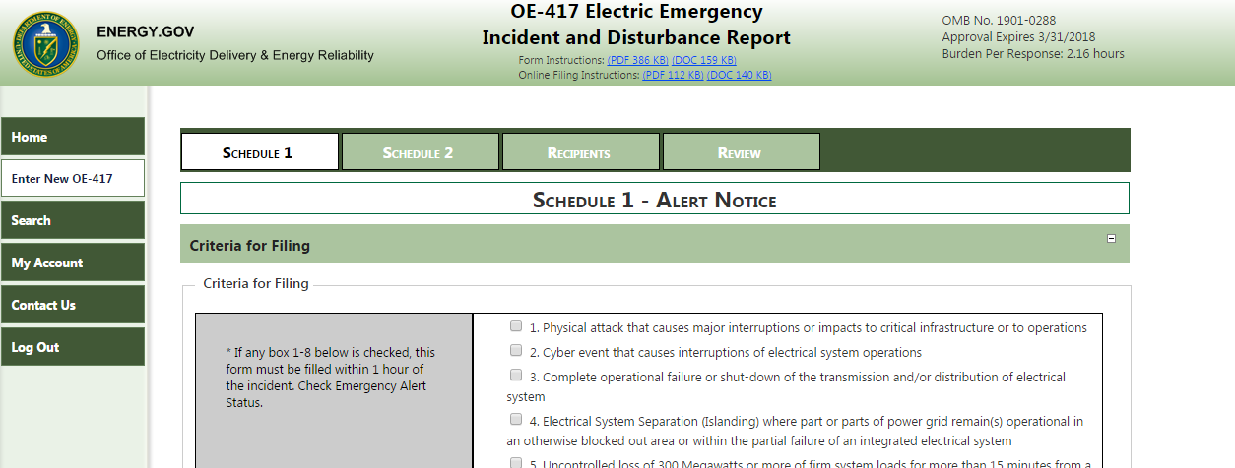

Updating Submitted Forms
Options | Description
1 | Locate the Form you need to update on your OE-417 Homepage Dashboard (Refer to Figure 1 – Updating a Form Part 1) if submitted within the last 30 days. Click the Update icon, and the selected Form will open. You can add, updated and modify any fields in the selected Forms that require updates and follow the Form submission process explained earlier.
2 | Enter the Event ID on your OE-417 Homepage (Refer to Figure 1 – Quick Search of Event ID), click Search, and your Form will open.. Continue to update Form the as described in Option 1.
3 | Go to the Search menu and enter your search criteria to find your Form. Click the Update icon next to the form and the Form will open. Continue to update Form the as described in Option 1.
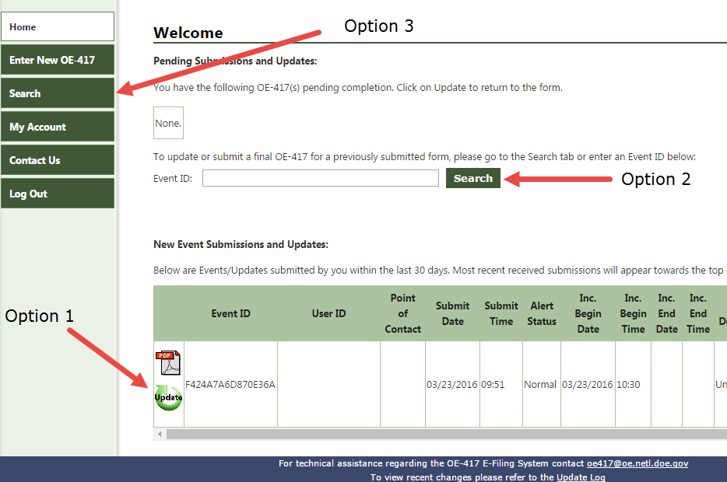

Save a Draft for Later Submission
In the new OE-417 E-Filing system the respondents have the ability save draft Form for later submissions which require two simple steps:
Step | Description
1 | When entering an OE-417 Form click “Save Draft” button on the bottom the screen anytime and your Form will be saved and displayed in your homepage  *Note: You must be signed in to the OE-417 e-filing system to save a draft
2 | When you are ready to submit a saved draft, click on the Update icon next to your draft on your home page and follow the Form submission process (Refer to Figure 1 - image above Saving a draft Part 2)
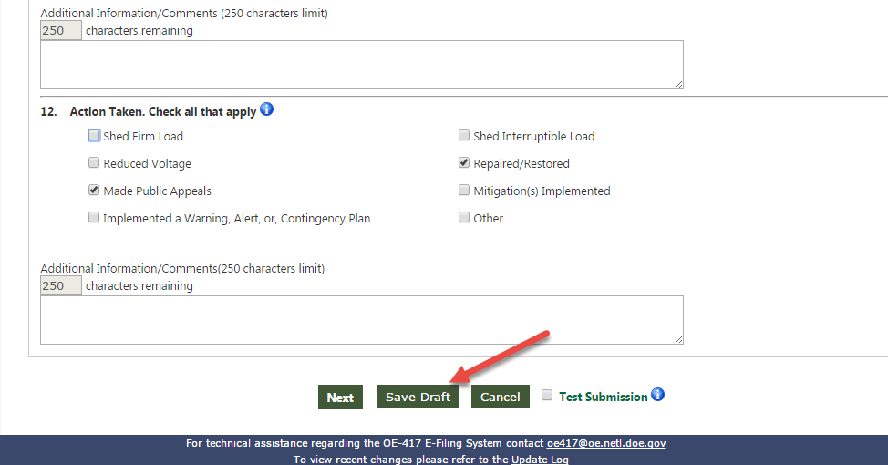

Submitting as a Guest
There is also an option to submit a Form as a guest user without registering for an account. Click on “Submit without registering an account.” Then follow step 3 under Submitting a New Form, above. The e-mail listed in the Official Contact will receive a copy of the Form submitted as a Guest.
Note: You will lose most of the benefits of the OE-417 E-Filing system if you submit as a guest as the information you submitted is not saved for updates and reference. Creating an OE-417 account is recommended to ensure full benefit of the system. If you wish to register after submitting a Form as a Guest, select the link on the Confirmation page after the Form was successfully submitted.

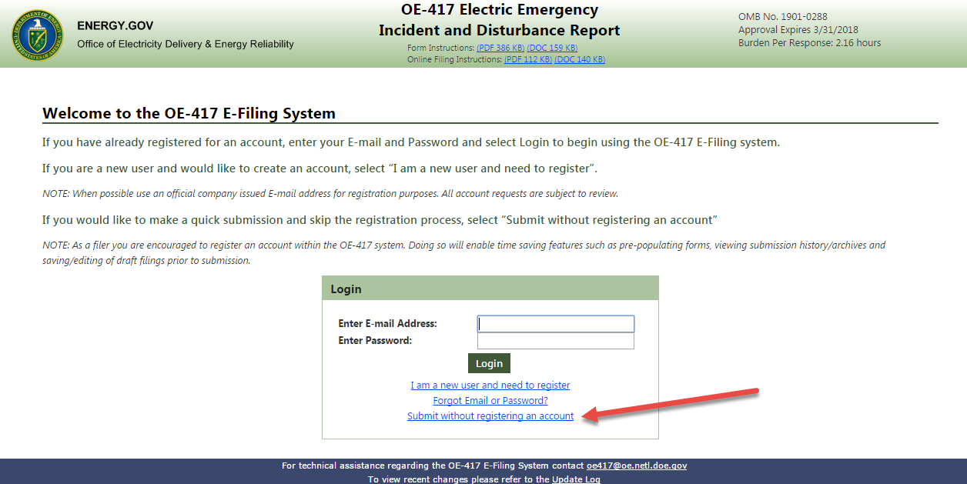

Submitting a Test
The E-Filing system can be used for testing and training. If the Form being submitted is only for testing purposes, click the box next to “Test Submission” located at the bottom of the Form. If a test Form is submitted, users will receive a test confirmation e-mail.. The submitted Test Form will also not be listed in the list of previously submitted Forms. You may search for your test submission by going to the Search menu and checking the “Test Submission Only” checkbox in your search criteria.

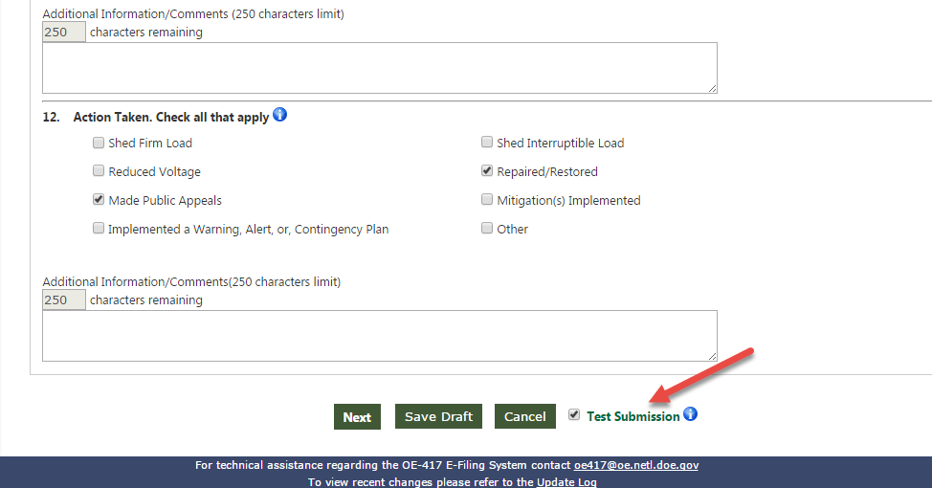

FAQ’s on Submitting an OE-417 Forms in the new system

- How can I enter a date/time on lines 5 & 6?
To enter a date/time on lines 5 & 6 click on the area to the right of “Date/Time Incident Began” and a box will appear displaying a calendar (see below). A user can select the date of the incident by clicking on the day with their mouse. To set the time, users will click and hold on the square next to “Hour” or “Minute” and while still holding down the mouse button, slide your mouse so the box moves to the right. Then the “Hour” will increase up to 23 (based on the 24 hour clock) and the “Minute” will increase up to 59. Click “Done” and the box will disappear.
Note: The system will not let users input a date/time in the future. So the sliding squares will only allow users to advance to the current time.

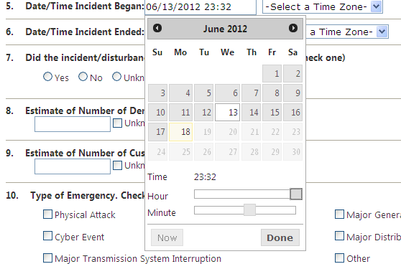

- How will I know if I have successfully E-Filed an OE-417 Form?
After submission, the system will display a confirmation page. If you have registered on the system, you will also receive an e-mail receipt confirming a successful transmission. Additionally, in the user’s OE-417 E-Filing “Home Page”, filings submitted within the last 30 days are visible or a user can click “Search” on the left hand bar to search their past filings.

- What fields are required to be filled out when completing an OE-417 Form?
Required fields for an Emergency, Normal, or Update Submission:
Criteria and Lines 1-5, 7, 13, 15, and 17

Required fields for a Final Submission:
Criteria and Lines 1-5, 7, 10-12, 13, 15, 17, and 18

- Do I need to submit a new OE-417 Form when updating or finalizing an event?
No, you should not open a new submission in order to update or finalize an initial submission. Simply perform a search using the Event ID of the event submission. Then click the “Update” next to the Form you wish to submit an Update or Final Submission for. This will open a Form with the previously submitted information already filled in. Select Update or Final in Form and you are able to make changes to it.
Please note this feature only applies to users who have made submissions using a registered OE-417 account.

- How will I be notified if the OE determines my submission was filed incorrectly?
If your submission is filed incorrectly, you will receive an e-mail or phone notification of the problem and what action is required to correct the submission.

- What should I do if I realize I made a mistake after completing a submission?
If you file a document incorrectly, please go log into the system, locate the submission, click the “Update” button, make the correction, and resubmit the Form as an Update.

Organization Management

The benefit to being part of an organization on the OE-417 E-Filing system is the ability to search, view and edit forms submitted by others in your organization. Members can also view drafts started by other members. A designated Organization Administrator can manage the users in their organization.

Becoming an Organization Administrator
In the registration page or if you are already registered in the My Account page, you may request to become an Organization Admin by clicking on the “Organization Admin” checkbox in the Organization Profile section. A System Administrator will get a notification of the request. Your profile will say “Admin – Pending” until approved. Once approved, your profile will change to “Admin – Approved”. You will also receive an e-mail notification when approved.

Organization Admin Responsibilities
Approving Members
Organization Admins will receive an e-mail notification when a new members registers in their organization. They can approve or decline the membership request in the “Join Organization Requests:” section from their homepage or from My Organization. The organization member will get an e-mail notification when they have been approved into the organization.

Approving other Organization Admins

Existing Organization Admins can also approve other Organization Admin requests of their organization. They can approve or decline the Organization Admin request in the “Join Organization Admin Role Requests:” section from their homepage or from My Organization.

Updating Organization Details

Organization Admins can go to the “Organization Details (Click to Expand/Collapse)” section in the My Organization page to update the organization’s name and address. This update will be reflected in all members’ profiles and will be prepopulated in future OE-417 forms. This will not change any organization details in forms previously submitted to DOE.

Managing Users

Organization Admins can view members, update their role and export a list of members from the My Organization page.
Roles can be changed under the Access Type dropdown next to the member’s name by selecting the updated role and clicking Save.
To export the list of member names, Organization Admins can click on the “Export Field (Click to Expand/Collapse), select the fields to export and click on View Export Data. The new page will show the exported fields and then click on Export to Excel to view export in MS Excel.
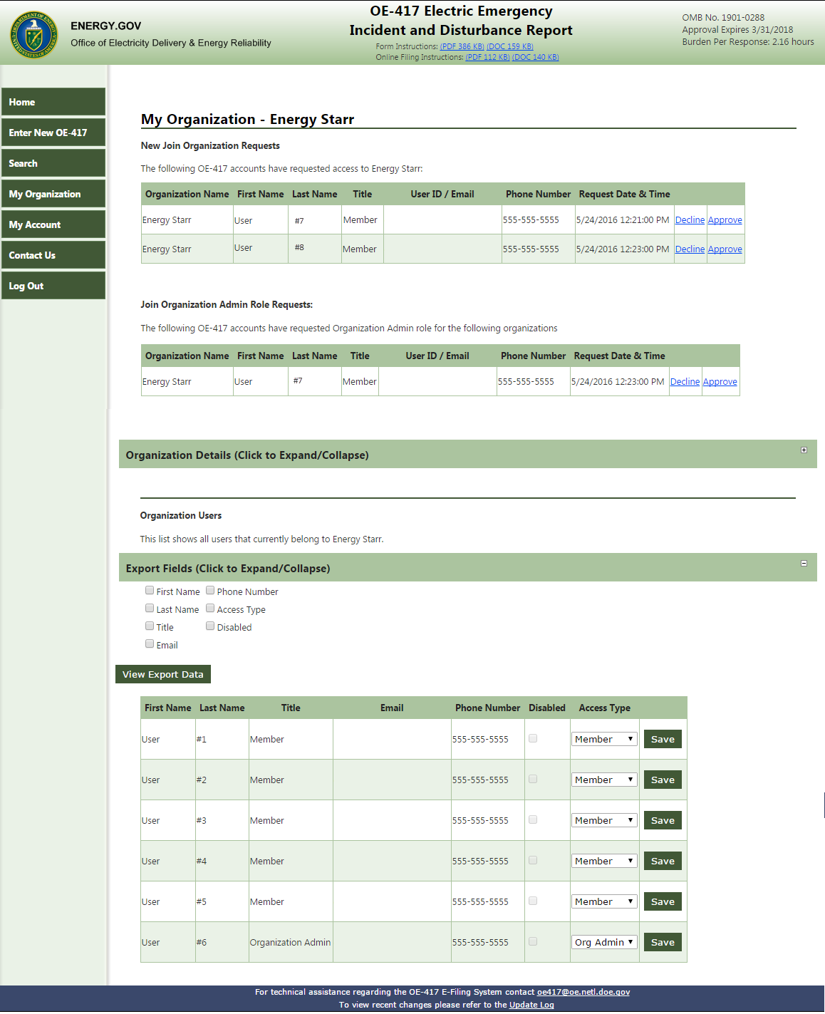

Other Features

Emailing the Form to NERC
As an added benefit, the respondent may approve sending the pdf copies of a completed OE-417 form to NERC. This information would be submitted to help fulfill the respondent’s requirements under NERC’s reliability standards (See Figure 2).

Search and Export Features
The OE-417 E-Filing system allows users to search and edit previously submitted Forms to assist users in updating existing Forms, additional reporting, and to reference historic Forms for analysis. Users can also export their search results.
Note: Only Forms submitted by your account will be searchable. If you are an approved member of an organization you will also be able to search for forms submitted by other members in your organization.

Figure 3
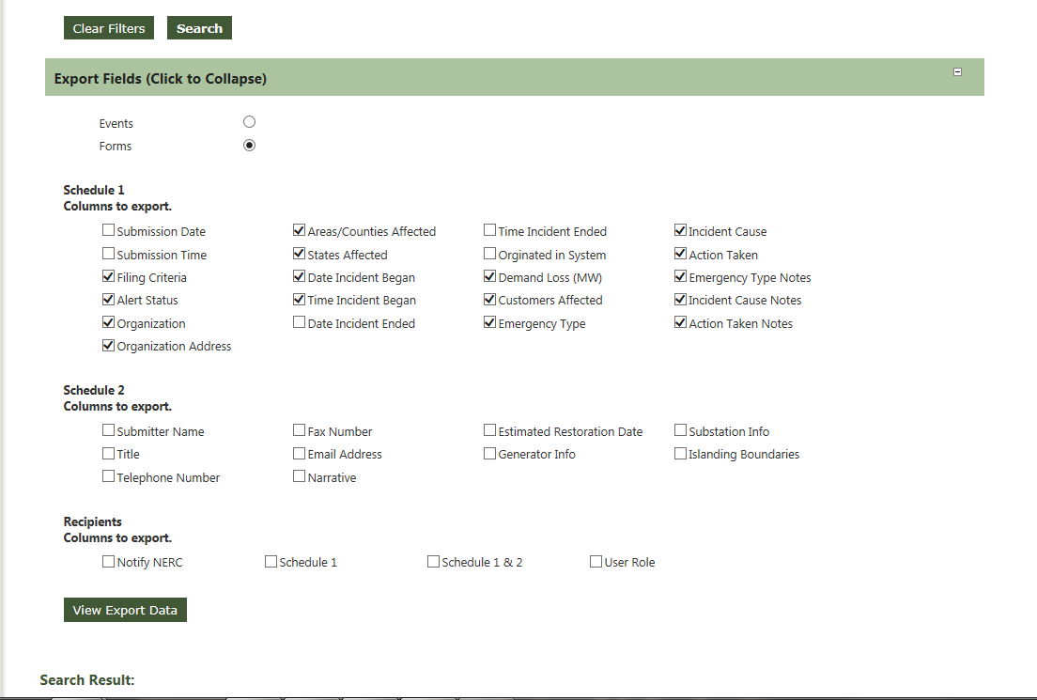

Step | Description
1 | Click the search tab on your homepage to initiate a search (Refer Figure 1 – Search Function)
2 | You can enter any of the following search criteria - Event ID, Begin/End Date Range, Organization Name, E-Mail Address, Peak MW Lost, Customers Affected, Criteria for Filing, Type of Emergency, Cause of Incident, Actions Taken, State, Alert Status or Test Submissions only and click search button and your search results will be displayed.
3 | To export your search results, click on “Export Fields (Click to Expand)” (See Figure 3). Select the fields to export.  For your convenience, the most common fields have been preselected. Click on View Export Data.
4 | From the View Export screen you can select Export to Excel to view your search results in MS Excel.

